Student’s Name:
Department:
Institution of affiliation:
Course Name:
Professor’s Name:
Date:

Table of content
Abstract……………………………………………………………………………. 3
Introduction………………………………………………………………………. 4
Processes…………………………………………………………………………….5
Production of steel…………………………………………………………………7
Advantage of the process…………………………………………………………. 10
Disadvantages of the process……………………………………………………… 11
Standards for steel…………………………………………………………………. 12
Reference…………………………………………………………………………… 14

Abstract
Steel has become the most vital raw material in modern industries due to its versatility, strength and it is relatively cheap. Verities of products manufactured or produced; Steel is the central supporting material used. Steel is majorly made up of irons and carbon, weighing approximately 0.2% and 2.1%, respectively. These components of steel are known as an alloy. The worth of steel in infrastructural industries and its contribution to economic growth is undeniable. How is steel produced? Well, steel is one of the most mass-produced materials in the modern world. Every year, approximately 750 million tons of steel are produced worldwide with less effect on the environment (Hoefer et al.,2018). Furthermore, the produced steel is recyclable and is relatively cheap to produce as it requires less energy in the process. This project will introduce and describe how the steel is manufactured and show how it is tested and measured.
Diagram of steel
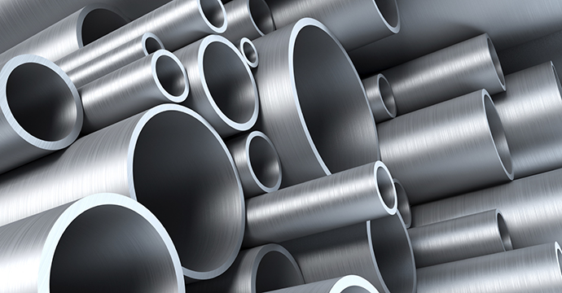
Introduction
Steel dominates both the construction and engineering industries as the main raw materials. In almost every aspect of human life, steel is used, starting from cars, washing machines, cargo ships to surgical scalpels and spoons. The good thing with steel is that it can be recycled. Moreover, it is relatively cheap since it does not consume much energy during its production and possesses great durability compared to other materials. Compared to steel production in the 1960s, steel production has greatly improved and enhanced environmentally friendly measures in its production. Steel is made from iron ore by removing oxygen and other impurities. Pure iron is then combined with carbon, recycled steel, and some amount of other relevant elements. This process passes through two routes, blast furnace-basic oxygen and electric arc furnace route. All these processes are discussed below.

Processes
Steel is produced by using two processes; Blast Furnace and Electric Arc Furnace. A blast furnace is largely used. However, an Electric Arc Furnaces process is majorly used to produce a special quality of steel.
Blast Furnace process
Henry Bessemer invented this process in 1850. He coined the term blast furnace from the process that involves blasting a hot air of about 1400 to 2100 degrees into the lower part of the furnace, which contains molten iron to oxidize the materials and do away with the heat impurities. The process reduces iron ore to iron. The process employs a steel cylinder lined with refractory, measuring about ninety meters in height. The cylinder is computer-controlled and filled with an environment control device. The blast furnace is considered to be the first method used to produce steel from iron oxides. This process uses iron ore, coke, and limestone to produce pig iron.
Step 1
Extracting iron ore
The process starts by finding a quality iron ore (Fe2O3). Then, the ore is mined and transported to the factory with a blast furnace.

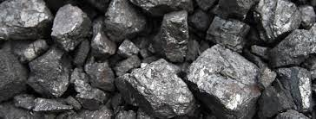
Diagram of Iron ore
The ore is blended to produce a favorable mix. The mix is combined with coke and heated to produce iron-rich material called sinter, a raw material for the blast furnace.
Step 2
Making iron
The two raw materials, iron ore, and coke meet each other at the blast furnace along with some limestone. Hot air is injected through tuyeres at the best of the furnace. The blast races the temperature in the furnace to about 2200C, which is needed for chemical reduction to form a pull of molten iron at the bottom of the furnace. The limestone combines with the impurities and floats at the top of the iron. The combination of limestone and impurities is known as slag. Molten iron is then tapped from the furnace. The slags are also removed as a waste product used in other industries such as road building or cement manufacturing companies.
The molten iron tapped from the furnace is not pure. Instead, it contains elements such as carbon, Sulphur, phosphorus, manganese, and silicon. To make steel, these elements must be removed from the molten iron because they are considered Impurities.
Diagram of Blast Furnace
Step 3
Basic Oxygen Steelmaking
This is the main process of refraining iron into steel.
- Scrapped steel is put into the vessel
- Molten iron is then added.
- Oxygen is bellowed into the melted oxygen at high speed. The oxygen combines with the impurities. This oxidation produces heat. Temperature is controlled by adding iron ore as a coolant. The oxidized carbon creates a carbon monoxide gas which is extracted and used as fuel. Other impurities are combined with lime that was added during the blow to form a slag. The quantity of the scrapped hot metal, lime, and other elements are then calculated to ensure the correct temperature and composition of the steel. Refining is then done by adding argon, nitrogen, or oxygen gases through the vessel's base. Alloying additions are made during tapping to adjust steel composition. During this stage, carbon is reduced from about 4% to about 0.05%. The vessel is then tilted to remove the slag for recycling.
Illustration of basic oxygen furnace in a diagram

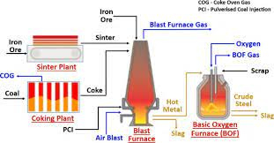
Step 4
Making steel
Electric Arc Furnace
This is another method of making steel. It uses coal steel scrap to make steel. The process is considered to be one of the largest world recycling processes.
- The furnace is filled with the recycled steel scrap
- The roof is swag into place to cover the funnel, and three graphic electrodes are lowered into the furnace.
- A powerful electric current then passed into the furnace.
- An arc is created, and the heat is generated to melt the steel scrap in the furnace.
- Lime is then added, and oxygen bellowed into the melt to separates impurities.
- The steel is then sampled and analyzed if it has reached the correct temperature.
- It is the tap of the furnace. At this stage, alloys can be added to meet the customer's specifications.
- Step 4
Secondary steelmaking
The process involves further refining of steel. The process aims at improving the temperature and consistency within the steel. In addition, the process allows the removal of gases such as Sulphur and allows the addition of alloys to ensures steel meets the desired specification.

Summary of the process in a diagram
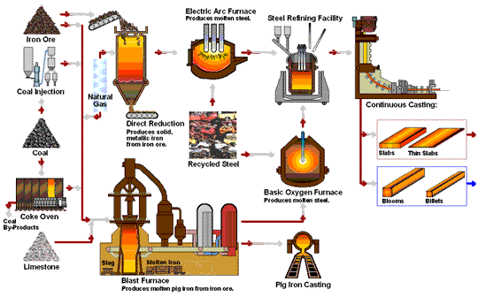

Step 5
Continuous Casting
This is the process that aims at solidifying steel ready for shaping. Molten material of steel is introduced into a mold and then allowed to solidify within the mold and then later ejected to produce or make fabricated parts. Melted steel is poured through a gas-tight refractory tube into a tundish. The melted steel is then passed through a numbered of water-cooled copper molds. The flow rate is controlled during this process, and only the outer shell of the steel solidifies as it passes through the copper mold. It is then drawn from the bottom of the mold through a curved arrangement of support draws and water sprays. The finished steel emergence horizontally and is cut into desired lengths by automatic gas banners. The solid shapes of the steel are named depending on their sizes. These names include Billet, Bloom, and slab, which are ready for shaping into finished products and use for different purposes.
Summary of continuous casting in a diagram
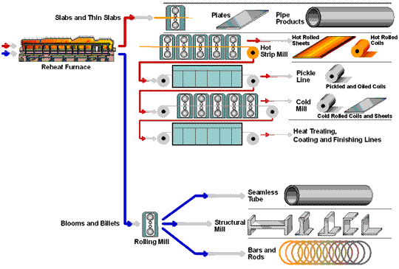

Importance of hot steel rolling
When cold, steel is high resistance to rolling. Therefore, rolling is done when the steel is still hot or in the molten state to make rolling easier. Before rolling, an analysis must be done to ensure that the steel is at the right temperature by filling it into a furnace where it travels through numerous temperature-controlled zones until the correct or desirable temperature has arrived. Then, the molten steel is squeezed through rolls until the desired shape and thickness are achieved. To enhance rolling, the rolls must exact millions of newtons equivalent to millions of tons of steel. The rolls run in massive bearings mounting to thousands of great strengths and driven by powerful electoral motives known as mills stand. The layout of rolling mails varies from a single simple stand to several stands. Depending on the product desired, the mill stand has varied roll arrangements. The rolling process is computer-controlled and is being monitored after every fifty times per second.

Standards for steel
The American Society for Testing and Materials (ASTM) has laid down steel standards to evaluate, classify, specify, chemical, metallurgical and mechanical elements of steel (ASTM Handbook, 2002). These standards are used production of industrial parts, mechanical components, construction elements, and all their related accessories. To mention a few the ASTM has developed standards on architectural metal fence systems, steel bars, Chain link fence, and wire accessories, machinery and piping systems, steel sheet specifications, stainless and alloy steel tubular products, steel plates for pressure vessels and boilers, among others (ASTM Handbook, 2002). Steel is a widely used material in the making of satellite systems, commercial transport aircraft, military aircraft, building and construction (sheets, poles, roofing, fences), making of home appliances such refrigerators, sinks, ovens, and televisions. Its strength, weldability, and recyclability make it a desirable commercial material.

Reference
Handbook of comparative world steel standards. ASTM. Bringas, J. E. (2002). [Accessed: April 5, 2021]
Hoefer, K., Haelsig, A., & Mayr, P. (2018). Arc-based additive manufacturing of steel components—Comparison of wire-and powder-based variants. Welding in the World, 62(2), 243-247.

